Data Preparation Assignment

With Case 31

- Please refer to Case 31 for this task.
- For data, use the SPSS file called, “Case 31 Data_efcu_1.sav” provided in BB.
- Submit your work via BB. Submit two files—SPSS data file (.sav) and the other SPSS syntax file (.sps).
  - Name the files by adding “Your Last name, First name” in front of the file name.
  - Make SPSS data file name the same as that of SPSS syntax file but with only the file extensions different.
- For new variables/modifications you make, make sure you save all the manipulations/computations in syntax file (.sps) by pressing ‘paste’ button as demonstrated in the class.
- Submit both your cleaned data file (.sav) and syntax file (.sps) to BB by the deadline.

Follow the steps you can follow to complete the data preparation task.

- Learn SPSS first. If you do not know how to maneuver SPSS, it will be difficult to this assignment.

To be able to do data preparation assignment for Case 31, you need to have basic understanding of SPSS. Followed is the topic. Go to the SPSS M01-M03 Module and learn SPSS.

SPSS M01-M03 SPSS Essential Training
M01. Getting Started (25m 45s)
M03. Modifying Data (44m 45s)

Upon successful completion of this module, you will be ready to prepare data for analysis by being able to do the following:

- Navigate the menu (in variable view and data view) including
  - Recognize the interface (variable name, type, label, values, measures, and role)
  - Setting options
  - Getting help
  - Reading data from a spreadsheet
- Modify Data by
  - Recoding variables
  - Reversing values with syntax
  - Recoding by ranking cases
  - Recoding with Automatic Recode
  - Creating dummy variables
  - Recoding with Visual Binning
  - Recoding with Optimal Binning
  - Computing new variables
  - Using Automatic data preparation

- Open up data file, “Case 31 Data_efcu_1.sav.” In “variable view tab” of the data file, locate “Measure” column. See the oval below. Most of the variables have been set as ‘Nominal’ type of scale. You need to judge for yourself if that is correct. If it is wrong, fix it.

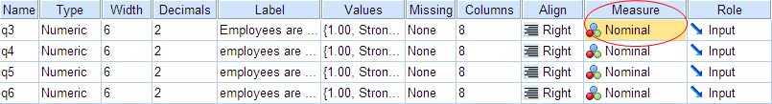

  - Recall that in “M07 – Measurement & Scale” module, you learned that there are four primary type of scale of measurement: Nominal scale, Ordinal scale, Interval scale, and Ratio scale. SPSS uses only three type – nominal, ordinal, and scale. “Scale” in SPSS means both interval and ratio scale.
  - If you do not know what these scale means, refer to the module and learn it. If you do not know the topic, you cannot do this task. To refresh your memory, here is the comparison table (Slide # 14 in PPT slide called, “Scales of Measurement.pptx.)

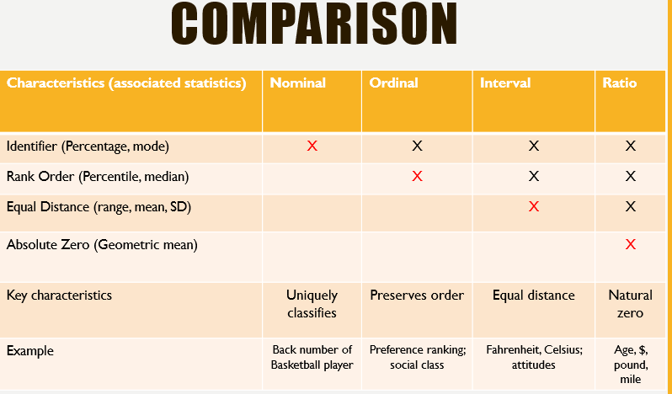

  - Once you are familiar with the concept, determine the type of scale for each variable starting with the first row – q3. To determine the type of scale, you need to see the question in the questionnaire for Case 31. Can you answer it? Looking at page 787 of the pdf file, we can see that Q3 (Thee Credit Union employees are courteous) is measured on 1 (Strongly Disagree) to 5 (Strongly Agree) point scale and each scale point (2, 3, and 4) have also specific description associated with it – 2 (Disagree), 3 (Uncertain), 4 (Agree). Q3 has the property of ordinal scale as each number can be ordered in size – 1 < 2 < 3 < 4 < 5. Next question is is the distance between any two adjacent scale points are the same? For example, is the distance between 1 (Strongly Disagree) and 2 (Disagree) the same as the distance between 4 (Agree) and 5 (Strongly Agree)? If so, the scale can be treated as interval. Since SPSS treat both interval and ratio scale as one category under ‘Scale,’ you need to set the measure for q3 to be ‘scale.’ Below is the first nine variables with ‘Measures’ column fixed.

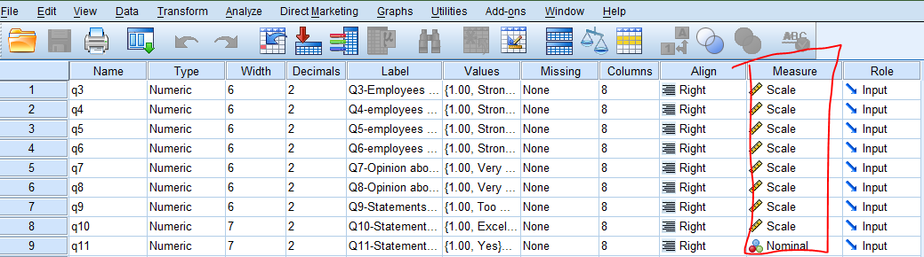

  - Go through this process for the rest of the variables in the “variable view” tab. It will take a while to do this. If you cannot determine the scale type, it is probably because you do not understand the difference between the scales. Review the concept again until you understand it.

- Go to the “Label” column (see below). The raw file has labels already entered in that column.

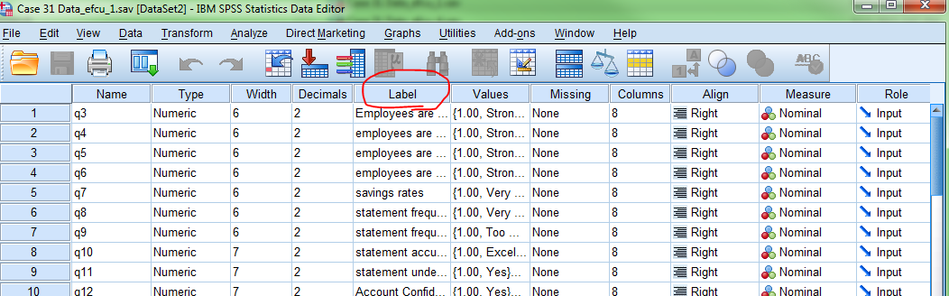

  - But it is cumbersome to have the label as they are. When you perform data analysis for a certain variable, say q3, SPSS will show you, the label name (Employees are courteous) by default, and you would wonder what the variable name associated with it is.
  - For this reason, it would be advisable to change labels in the way that makes sense for you.
  - Here is what I would do. See under “Label”

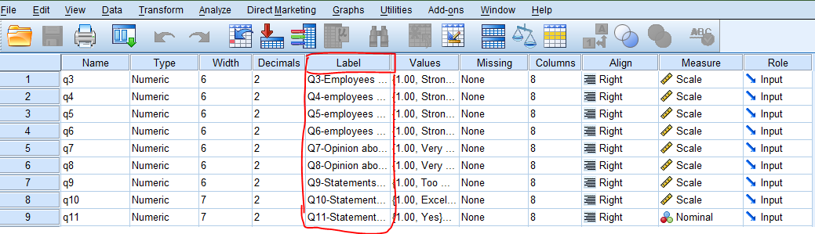

  - Go through the same process and change the labels for the rest of the variables. Refer to the questionnaire whenever you need to know the variable. Here variable and the question in the questionnaire are the same thing.

- Go to the “Values” column (see below).

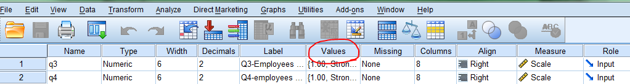

  - Here “values” means numeric value associated with each category of the variable. For example, for q3 variable, let’s locate “values” cell for the variable. You will down arrow shows the cell. If you click the right side the cell, approximately the very place where you see the red colored down arrow, a small window will pop up. The window has a title, ‘Value Labels.” Provide labels for these values as seen below.

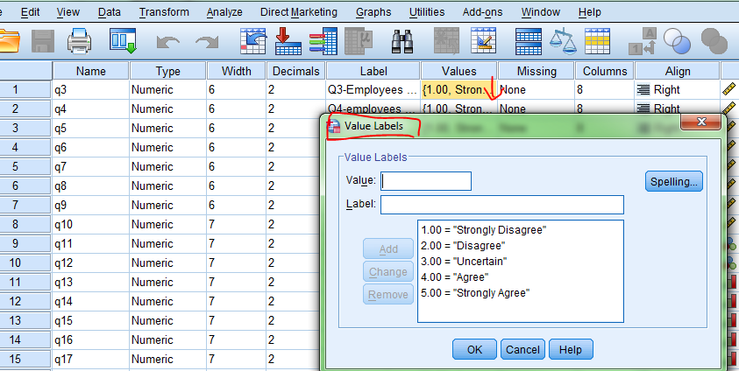

  - For the variables with interval scale, you don’t need to provide labels for the values as long as you can easily recall scale. For example, variables like q3 was measured with Likert type scale with 1 to 5 point scale. It is so predictable. I can exactly recite labels for 1 through 5. So there is no benefit of labeling the values. However, you may want to have labels if the scale does not follow a conventional pattern. Here is an example. Here 1 = “Very High,” which is unconventional.

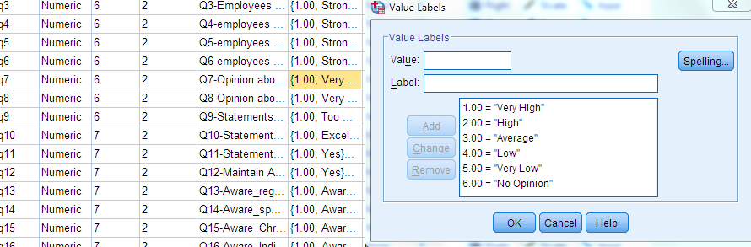

  - For all variables measured with nominal scale, assign labels for the values that represent categories.
    - q11
    - q12
    - q27
    - q28
    - q38
    - q39

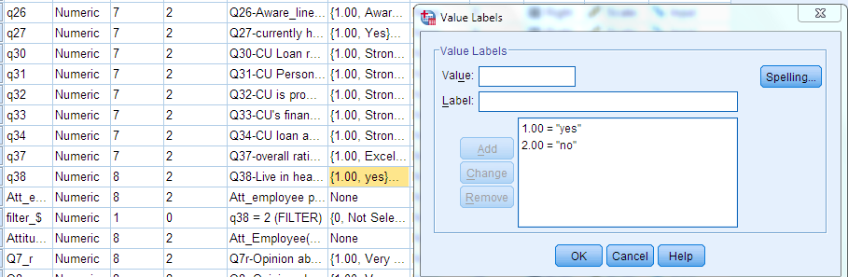

* Note: From now on, you are advised to keep track of data modification by evoking syntax file. To have SPSS record your command, you need to click “Paste” instead of clicking “Ok”

- For all the variables whose scales are reversed, create new variables by reversing scales such that the magnitude of the measures match with that of the scales used. There are two ways to do this.

  - Use Transform > Recode into different variables :
This method can be used efficiently for reverse coding when there is “no opinion,” or “not applicable” in the question options. “no opinion,” or “not applicable” should be changed to “system missing.” (see BB, “M05 - data preparation/manipulation” folder under “course content for a short vide on recoding: Course Content > Research Methods-Chapter Materials > M05 - Data Preparation/Modification. Also refer to SPSS Essential Training in Lynda.com.)
- q7 → q7r
- q8 → q8r
- q37 → q37r
  - Use Transform > Compute variables:
This method can be used effectively when there are no question items that do not make sense when reversing: “no opinion,” or “not applicable.” Under this circumstance, computation can be done by using “new variable name = (# of question items + 1) – old variable name.” (See BB, “M05 - data preparation/manipulation” folder under “course content for a short vide on transform: Course Content > Research Methods-Chapter Materials > M05 - Data Preparation/Modification. Also refer to SPSS Essential Training in Lynda.com.)
    - q9r = 6 – q9
    - q10r = 5 – q10
    - q13r = 4 – q13
    - q14r = 4 – q14
    - q15r = 4 – q15
    - q16r = 4 – q16
    - q17r = 4 – q17
    - q18r = 4 – q18
    - q19r = 4 – q19
    - q20r = 4 – q20
    - q21r = 4 – q21
    - q22r = 4 – q22
    - q23r = 4 – q23
    - q24r = 4 – q24
    - q25r = 4 – q25
    - q26r = 4 – q26

  - Under the variable view tab of the SPSS data file, provide label for the variable name and labels for variable categories.

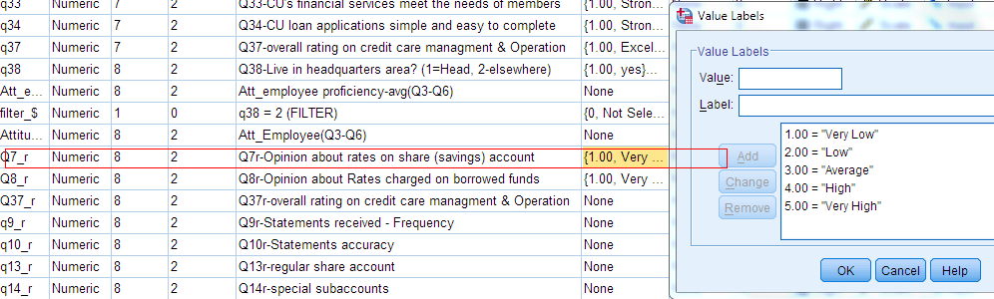

- For all multi-item measures (e.g., attitude towards employee proficiency), perform reliability and factor analysis. If the measure shows high reliability, make composite scale by averaging them out. You can accomplish this by creating a new variable using Transform > Compute variables. For example, for the attitude towards employee proficiency, you can sum q3 through q6 and divide it by 4 (alternatively, you can use “mean” function in SPSS), the number of variables (see below the syntax file).
